SVKM'S NMIMS Nilkamal School of Mathematics, Applied Statistics & Analytics

Master of Science (Data Science)

Practical-4 Storage as a service using AWS.

ARISHA AKHTAR- A041

**Date :- 05/03/2024 Submission Date :- 07/03/2024**

**Write up :-**

* **Storage as a service-s3**

Amazon Simple Storage Service (S3) is a widely used Storage as a Service (SaaS) offering by Amazon Web Services (AWS). S3 provides a scalable and durable object storage solution that allows users to store and retrieve data over the internet. With a focus on high availability, S3 ensures 99.999999999% durability by replicating data across multiple servers and facilities. Users can easily scale their storage needs, starting with a minimal amount and expanding as their requirements grow. Security features such as access control lists, bucket policies, and AWS Identity and Access Management provide robust control over data access. S3's versatility makes it suitable for various use cases, including data backup, archiving, content distribution, and analytics. Objects are stored with unique keys in a flat, non-hierarchical structure, and users can take advantage of features like versioning and lifecycle management. S3's straightforward setup, reliability, and accessibility make it a fundamental component for cloud-based applications and services, offering simplicity and cost-effectiveness in managing data in the cloud.

* **S3 use cases**

**Data Backup and Archiving:** S3 is often used for data backup and archiving purposes. Its high durability ensures that data remains intact, and versioning support allows for easy recovery of previous versions of objects.

**Web Hosting and Content Distribution**: S3 can be used to host static websites or distribute content globally. By leveraging S3's content delivery features, such as Amazon CloudFront, users can deliver static and dynamic web content with low latency and high transfer speeds.

**Big Data Analytics**: S3 is commonly employed as a data lake for big data analytics. It allows organizations to store vast amounts of raw and processed data, making it accessible for analysis using services like Amazon Athena, Amazon Redshift, or third-party analytics tools.

**Media Storage and Distribution**: S3 is suitable for storing and distributing multimedia files such as images, videos, and audio. Its scalable architecture ensures seamless handling of large media files, and the integration with CloudFront facilitates efficient content delivery.

**Application Hosting**: Developers use S3 to store and retrieve data for cloud-based applications. It provides a reliable and scalable storage solution for applications hosted on AWS, supporting features like static website hosting and application data storage.

**Disaster Recovery**: S3 is a key component in building robust disaster recovery solutions. By replicating data across different AWS regions, organizations can ensure data availability even in the event of a regional outage.

**Data Migration**: S3 is often involved in data migration projects. Users can upload large datasets to S3 and then transfer the data to other AWS services or on-premises systems efficiently.

**Log Storage and Analysis**: S3 is used to store log files generated by various applications and services. Combined with services like Amazon CloudWatch and AWS Lambda, organizations can analyze logs for insights, troubleshoot issues, and monitor system performance.

**Collaborative Workflows**: S3 supports collaborative workflows by providing a centralized repository for shared documents, images, and other collaborative assets. Teams can use S3 to store and share files securely.

**IoT Data Storage**: S3 is suitable for storing large volumes of data generated by Internet of Things (IoT) devices. It allows organizations to capture, store, and analyze IoT data efficiently.

These use cases demonstrate the flexibility and adaptability of Amazon S3 across diverse scenarios, making it a foundational service for various industries and applications in the cloud.

* **Steps for s3**

To use Amazon S3 effectively, you can follow these general steps:

Sign Up for AWS: If you don't have an AWS account, sign up for one at https://aws.amazon.com/. You'll need to provide billing information, but many AWS services, including S3, offer a free tier with limited resources.

Access AWS Management Console: Log in to the AWS Management Console using your account credentials.

Navigate to S3: In the AWS Management Console, find and select the "S3" service under the "Storage" category.

Create a Bucket: In the S3 dashboard, click the "Create Bucket" button. Give your bucket a unique name (S3 bucket names are globally unique) and choose the region where you want the bucket to be located.

Configure Bucket Properties: Set up additional configurations for your bucket, such as versioning, logging, and tags. Versioning is especially useful for data backup and recovery.

Set Permissions: Define access permissions for your bucket. This includes setting bucket policies and access control lists (ACLs) to manage who can access your data and what they can do with it.

Upload Objects to the Bucket: Once your bucket is set up, you can upload files, also known as objects, to it. You can either use the web interface to upload individual files or leverage AWS SDKs and command-line tools for larger-scale uploads.

Configure Object Properties: Set metadata and configure properties for your uploaded objects, including storage class, encryption, and access control.

Manage Objects: Use the S3 console to manage your objects, including copying, moving, and deleting. You can also organize objects into folders within your bucket.

Enable Versioning (Optional): If you want to enable versioning for your bucket, allowing you to keep multiple versions of an object, you can do so in the bucket properties.

Enable Logging (Optional): If you want to log access to your S3 bucket, configure logging settings in the bucket properties.

Set Up Lifecycle Policies (Optional): Define lifecycle policies to automatically transition objects to different storage classes or delete them after a specific period.

Secure Access with AWS Identity and Access Management (IAM): Use IAM to control access to your S3 resources. Create IAM users and roles with appropriate permissions to ensure secure access.

Integrate with Other AWS Services (Optional): Explore integrations with other AWS services. For example, you can connect your S3 bucket with AWS Lambda, CloudFront for content delivery, or AWS Glue for data processing.

**Implement S3 for :**

1. **uploading a file, video, etc.**

Open AWS Console and select S3 Storage

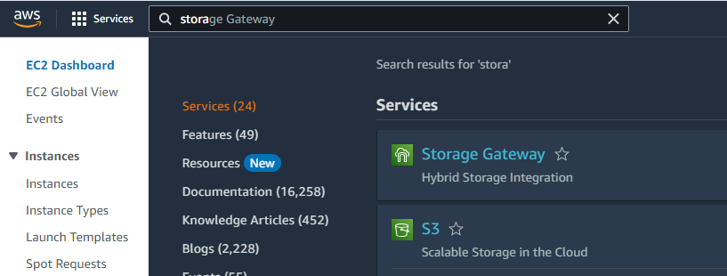

On S3 page click on “Create bucket”

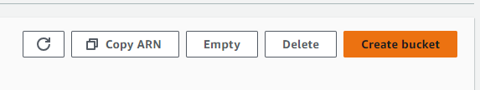

Select the desired region and give your bucket name

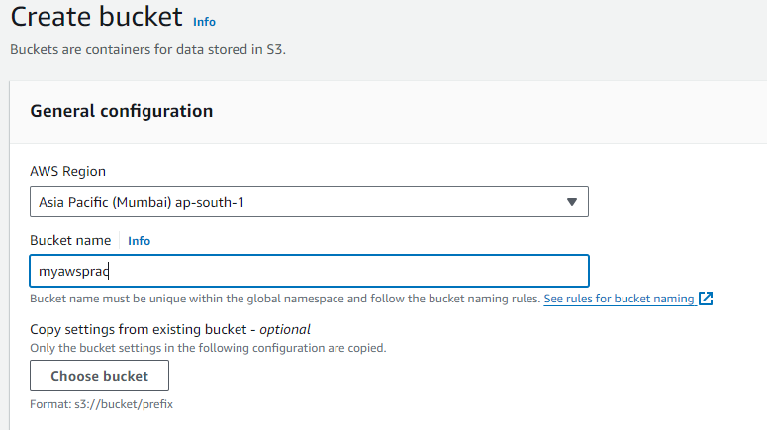

Verify that the bucket is created

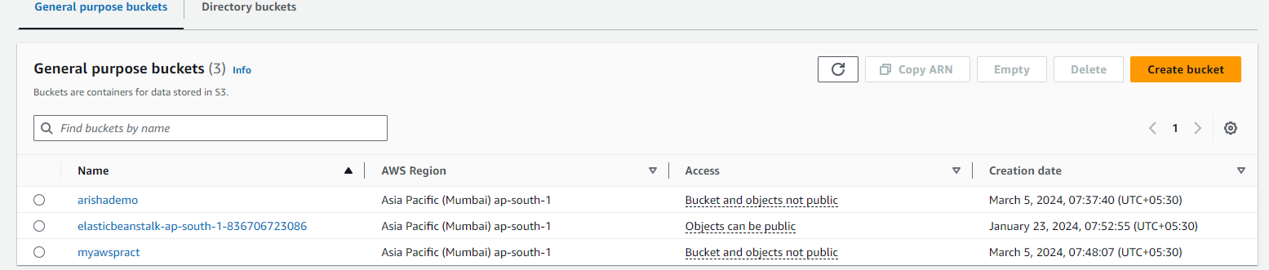

Click on Upload file

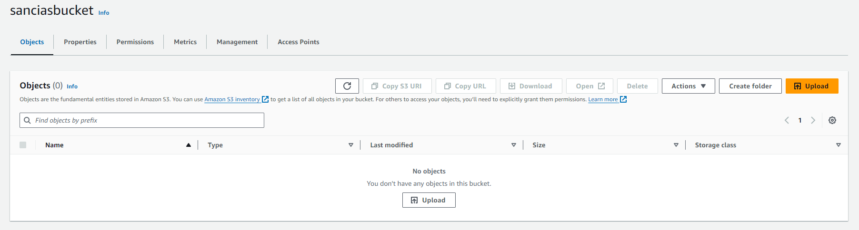

Click on Add Files and upload any downloaded image/pdf/videos, etc.

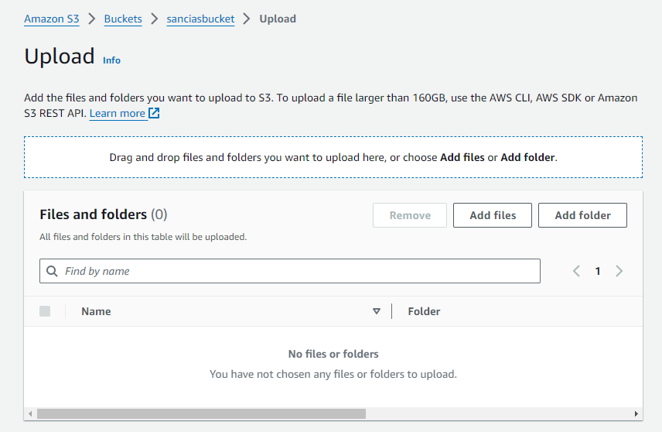



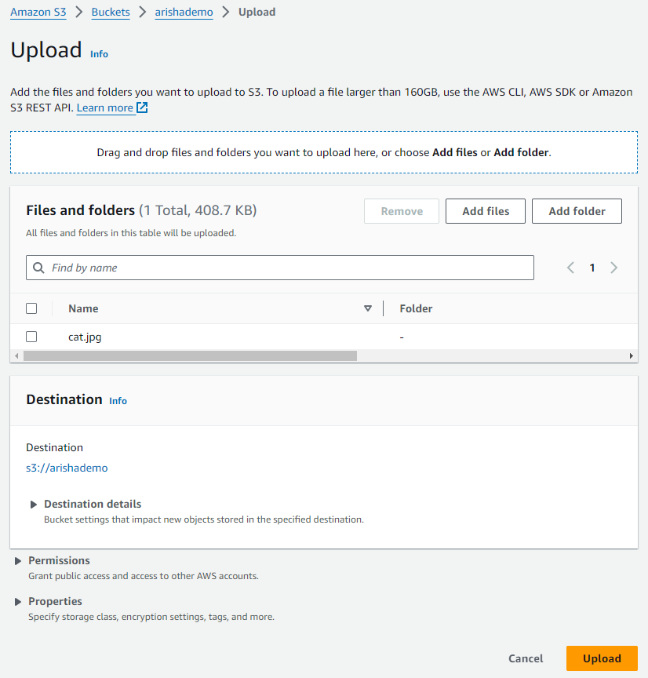

After Uploading verify if the image has been uploaded

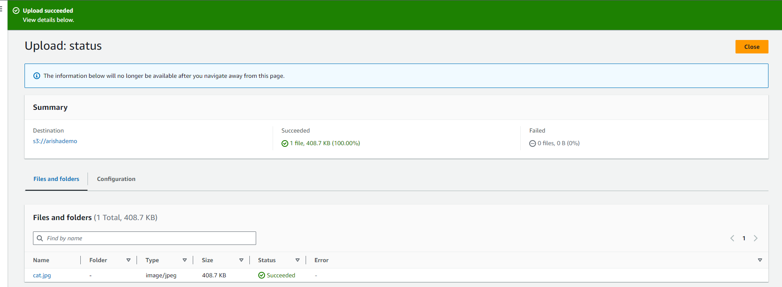

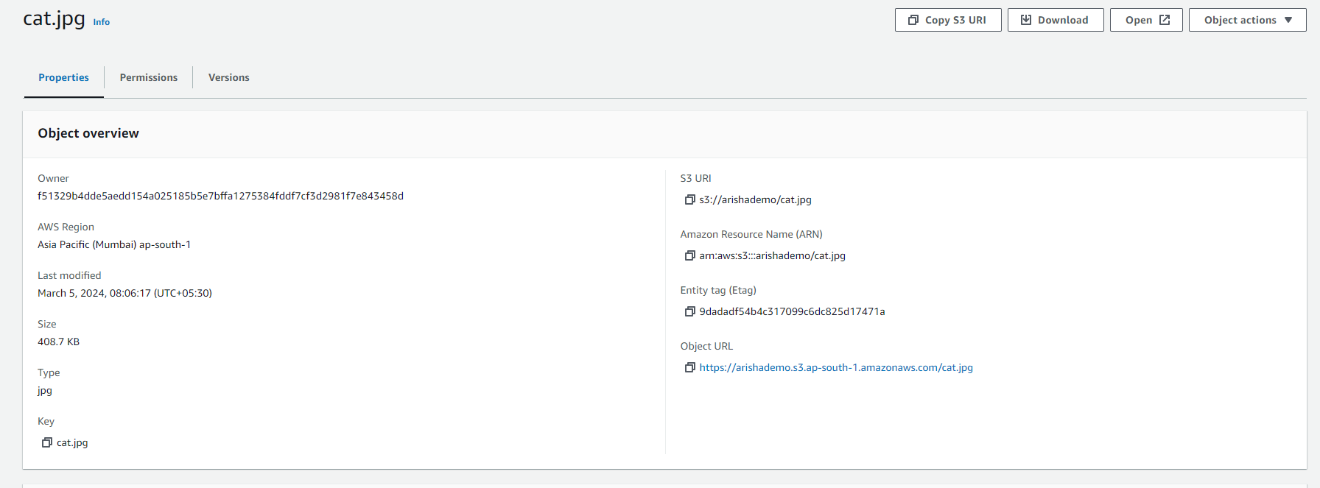



1. **uploading a static website**



